Project Proposal
Name: Sharon Rosina Wamalwa
Instructor: Thomas Tiahrt
Institution: University Of South Dakota
Course: Data Mining DSCI 724.
Submission Date: 10/26/2025
Cancer Type Prediction: Analyzing the Impact of Lifestyle, Genetic, and Environmental Factors on Cancer Type Prediction.
Introduction
Cancer risk is influenced by a combination of behavioral, genetic, and environmental factors, many of which are measurable and increasingly used for early risk assessment (World Health Organization [WHO], 2024). Research shows that lifestyle indicators such as smoking, alcohol consumption, obesity, and physical inactivity contribute significantly to cancer development .In addition, hereditary factors such as BRCA mutations and family cancer history play a critical role in risk elevation, particularly for breast and ovarian cancers (American Cancer Society, 2023). Environmental factors, including air pollution and occupational exposure to carcinogens, have also been associated with elevated cancer.
As cancer risk varies significantly across individuals, developing predictive models can assist in risk stratification and early intervention planning. By estimating a person’s overall risk score using measurable attributes, such models can support preventive strategies before cancer manifests clinically.
This project aims to predict an individual’s overall cancer risk score based on lifestyle habits, genetic history, and environmental exposure using a multiple linear regression approach.

Data Source
This study will utilize the publicly available Cancer Risk Factors & Types dataset sourced from Kaggle.
https://www.kaggle.com/datasets/tarekmasryo/cancer-risk-factors-dataset
The dataset contains 2,000 individual records and 21 features, including lifestyle behaviors, medical history, biological measurements, and environmental exposures.
It also includes engineered risk indicators such as Overall_Risk_Score (0–1 scaled) and Risk_Level (Low, Medium, High). Each row represents a single individual’s risk profile and associated diagnosed cancer type.

Response Variable (Dependent Variable)
Variable | Description | Type
Overall_Risk_Score | Composite numerical score estimating the likelihood of cancer development (range 0–1) | Continuous

Predictor Variables (Independent Variables)
At least two predictors will be used, with the final model potentially exploring all available risk indicators:
Predictor | Description | Type
Age | Age of individual | Continuous
BMI | Body Mass Index | Continuous
Smoking | Smoking status | Binary (0/1)
Alcohol_Use | Alcohol consumption | Binary (0/1)
Obesity | Obesity condition | Binary (0/1)
Family_History | Cancer in family | Binary (0/1)
BRCA_Mutation | Presence of genetic mutation | Binary (0/1)
Air_Pollution | Exposure to polluted environment | Binary (0/1)
Occupational_Hazards | Exposure to carcinogenic work conditions | Binary (0/1)
H_Pylori_Infection | Presence of infection linked to gastric cancer | Binary (0/1)
Physical_Activity | Activity level | Binary (0/1)

Evaluation Metric
Since multiple linear regression will be used, the following evaluation metrics will assess model performance:
Primary Metric:
- R² (Coefficient of Determination): Indicates how much variation in the cancer risk score is explained by the predictors.
Secondary Metrics:
- Adjusted R²: Adjusts for the number of predictors in the model.
Descriptive Statistics
# Install flextable if not already installed
if (!require(flextable)) install.packages("flextable")
library(flextable)

# Define continuous variables
cont_vars <- intersect(c("Overall_Risk_Score","Age","BMI"), names(eda_df))

cat("\n=== Means & Standard Deviations (Continuous) ===\n")

if (length(cont_vars) > 0) {
cont_summary <- eda_df %>%
summarize(across(all_of(cont_vars),
list(mean = ~mean(.x, na.rm = TRUE),
sd = ~sd(.x, na.rm = TRUE)),
.names = "{.col}__{.fn}")) %>%
pivot_longer(everything(),
names_to = c("Variable", ".value"),
names_sep = "__") %>%
arrange(Variable)

# Convert to flextable
cont_table <- flextable(cont_summary)
cont_table <- autofit(cont_table)

print(cont_table)
} else {
cat("No continuous variables found.\n")
}

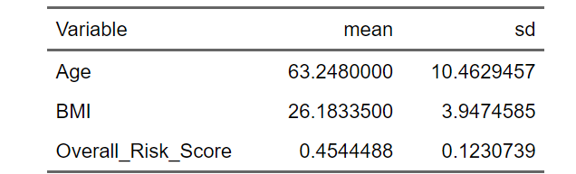

The descriptive statistics show that the average age of individuals in the dataset is approximately 63.2 years (SD ≈ 10.5), indicating a predominantly older population.
The mean BMI is around 26.2, which falls within the overweight range (25–29.9), with moderate variation (SD ≈ 3.95).
The Overall_Risk_Score averages at 0.454 (SD ≈ 0.123), suggesting that most individuals fall within a moderate cancer risk category. The relatively small standard deviation for risk score indicates limited variability, which may still be sufficient for regression modeling.

BOX PLOT USING TUKEY’S FIVE NUMBER SUMMARY
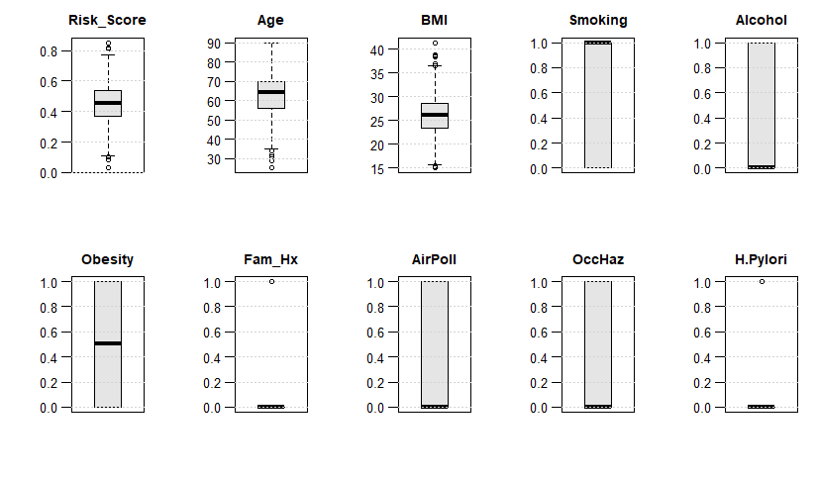
NOTE: The code is too long so I did nit copy it in the proposal

Summary from the box plots
The boxplots indicate that the response variable (Overall_Risk_Score) and key continuous predictors (Age and BMI) demonstrate meaningful variability suitable for regression modeling.
Binary predictors such as smoking, alcohol use, family history, and environmental hazards reflect distinct subgroups, may serve as effective explanatory factors.
The presence of outliers in BMI and certain binary conditions suggests individual-level variability that could impact cancer risk predictions.
Pearson Product-Moment Correlation Matrix Interpretation
# --- Pretty Pearson correlation table with flextable ---

# 1) Round and (optionally) keep only the upper triangle for compactness
corr_rounded <- round(corr_mat, 3)

# Set lower triangle (excluding diagonal) to NA to reduce clutter (optional)
keep_upper_only <- TRUE
if (keep_upper_only) {
corr_rounded[lower.tri(corr_rounded)] <- NA
}

# 2) Convert to data frame with rownames preserved
corr_df_print <- data.frame(Variable = rownames(corr_rounded), corr_rounded, check.names = FALSE)

# 3) Flextable (small font + autofit so it fits on screen)
if (!requireNamespace("flextable", quietly = TRUE)) install.packages("flextable")
library(flextable)

ft_corr <- flextable(corr_df_print)
ft_corr <- autofit(ft_corr)
ft_corr <- fontsize(ft_corr, size = 9, part = "all") # shrink to fit
ft_corr <- align(ft_corr, align = "center", part = "all")
ft_corr <- bold(ft_corr, part = "header")

# Optional: freeze the first column (row labels) visually
ft_corr <- bg(ft_corr, j = "Variable", bg = "#F5F5F5")
ft_corr <- align(ft_corr, j = "Variable", align = "left")

ft_corr # <- prints a single, scrollable table that fits nicely
The correlation matrix shows the linear relationship between the response variable (Overall_Risk_Score) and the selected predictors.
This means Even though individual predictors are weakly correlated with the risk score, the multiple linear regression model may still capture combined effects across variables.

All predictors may remain in the model, as none violate the collinearity rule.
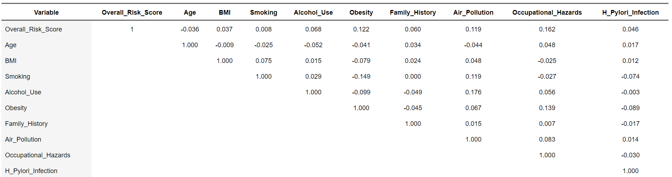

The correlation matrix
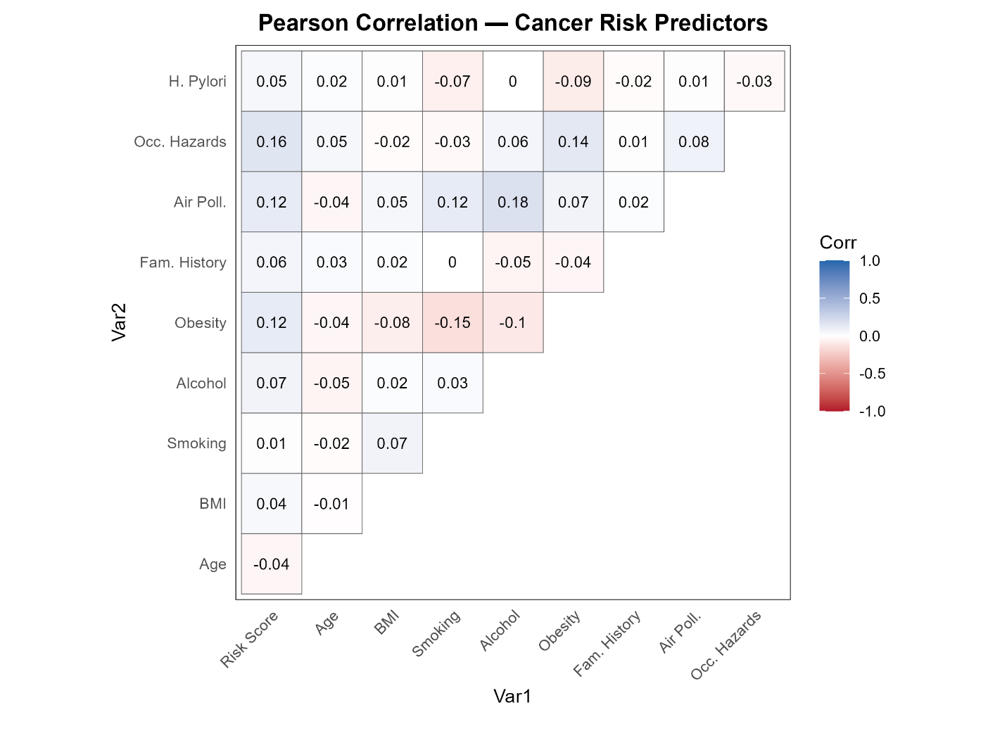

References
World Health Organization. (
https://www.who.int/news-room/fact-sheets/detail/cancer

American Cancer Society. Cancer Risk Factors
https://www.cancer.org/cancer/risk-prevention.html

